**Kendriya Vidyalaya sangathan**



**Academic year 2020 -2021**

**Project on ELECTRICITY BILLING SYSTEM**

**ROLL NO :**

**NAME : HARSH SINGH**

**GROUP MEMBERS : PRABHAT & RAKESH**

**CLASS : XII-G**

**SUBJECT : COMPUTER SCIENCE**

**SUB CODE : 083**

**SUBMITTED TO: - Mr. HIMANSHU SEHGAL**

**Certificate**

This is to certify that Candidates **Harsh Singh** CBSE Roll No:_________________ has    successfully  completed the project Work entitled **ELECTRICITY BILLING SYSTEM** in the subject Computer Science (083) laid down in the regulations of CBSE for the purpose   of    Practical   Examination in   Class XII  to  be held in  KV AGCR COLONY on______________.

**Signature of External Examiner**

**Name** : _______________________

**Examiner Number** : ______________

**ACKNOWLEDGEMENT**

Apart from the efforts of me, the success of any project depends largely on the encouragement and guidelines of many others. I take this opportunity to express my gratitude to the people who have been instrumental in the successful completion of this project.

I express deep sense of gratitude to almighty God for giving me strength for the successful completion of the project.

I express my heartfelt gratitude to my parents for constant encouragement while carrying out this project.

I gratefully acknowledge the contribution of the individuals who contributed in bringing this project up to this level, who continues to look after me despite my flaws,

 I would like to express my special thanks of gratitude to my teacher Himanshu sir who gave me the golden opportunity to do this wonderful project on the topic Electricity billing system which also helped me in doing a lot of Research and i came to know about so many new things I am really thankful to them.

**Source code :-**

Program for Electricity billing system 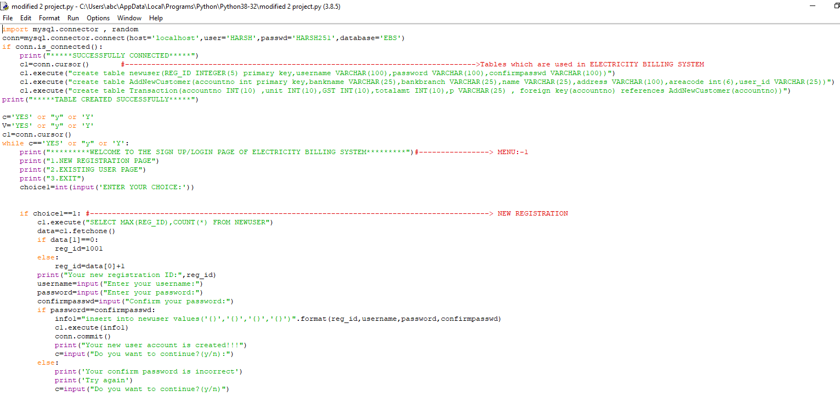

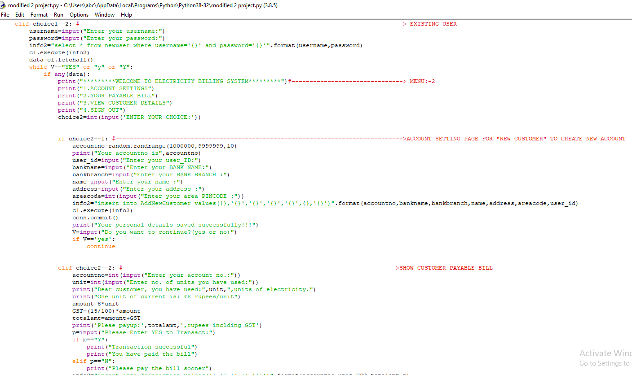

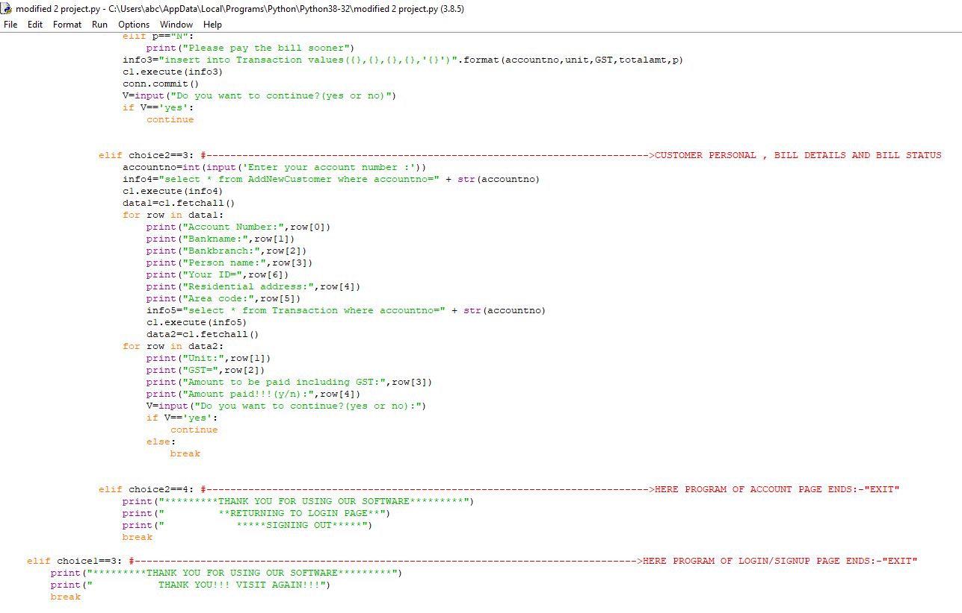

**Output :-**

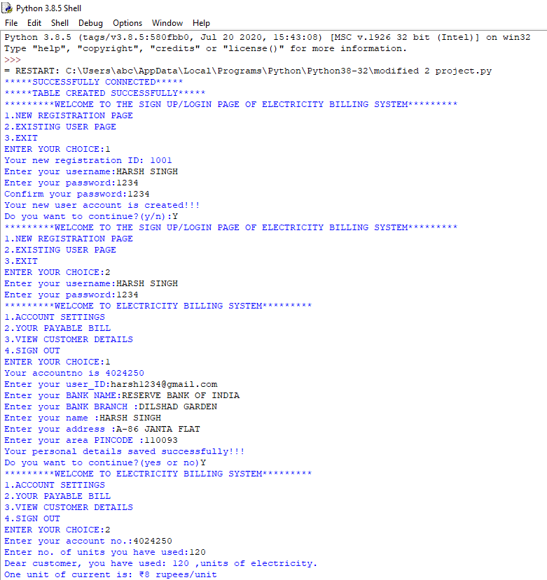

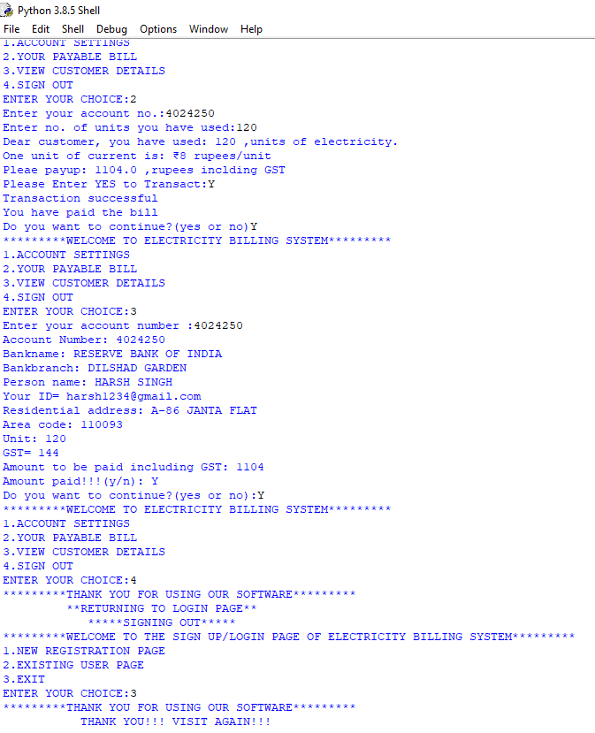

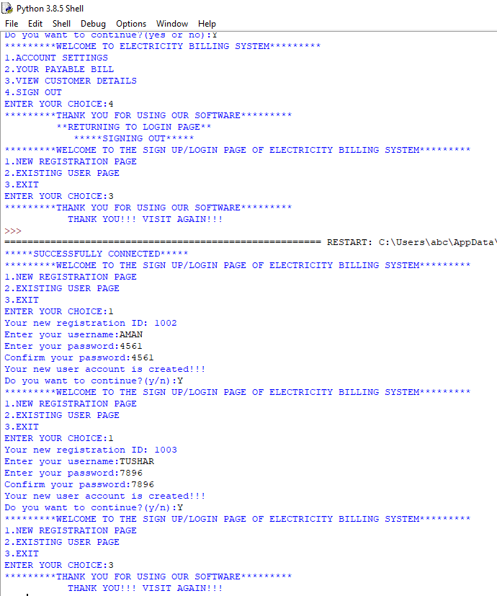

**SQL OUTPUT :-**

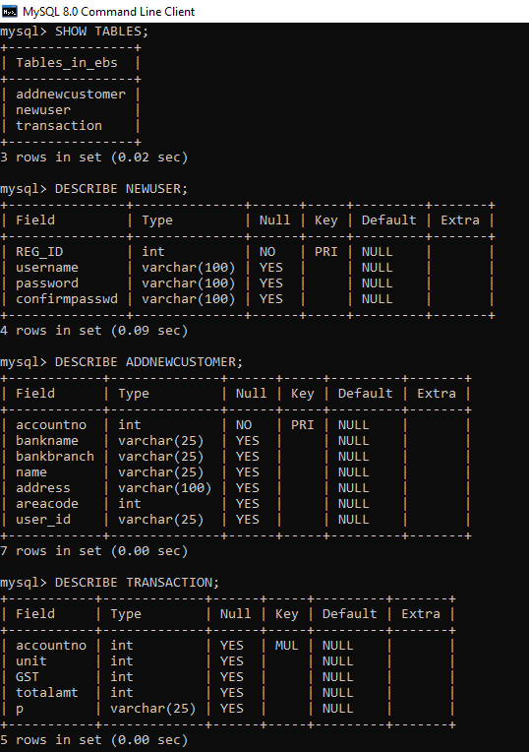

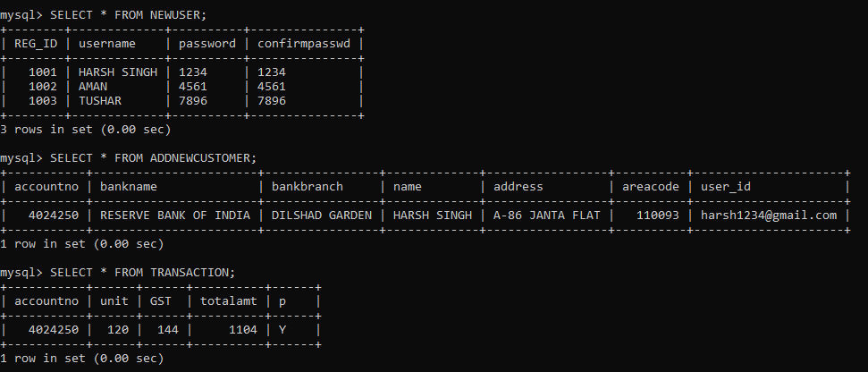

* **LINK FOR THIS PROJECT:-**

<https://drive.google.com/file/d/1PGpRqd1taBCaMP_c4nd4e0Vw0csj6Cp-/view?usp=sharing>

* **LINK FOR PRACTICAL QUESTIONS:-**

<https://drive.google.com/file/d/11osaIh99XKphg36WxaU72j2OAXtf6ppE/view?usp=sharing>